**Use Case: FMCG Distribution Insights Dashboard for Luson Blu**

Client Background

Luson Blu is a major fast-moving consumer goods (FMCG) distributor in Nigeria. They operate across multiple regions and channels, serving a wide range of customers. Despite their scale, they faced challenges in gaining visibility into product performance, customer behavior, and warehouse efficiency.

**Business Challenge**

* The leadership team needed better insights into:
* Product profitability
* Channel performance over time
* Inventory risk and stockouts
* Customer segmentation behavior
* Trend deviations across regions

**My Role**

* As the Data Analyst, I was responsible for:
* Cleaning and transforming data using Power Query.
* Modeling a star schema.
* Creating insightful DAX measures.
* Designing an interactive Power BI dashboard.
* Delivering a concise 1-page insight report.

**Solution Approach**

Power Query Transformation:

Removed duplicates in Sales_Data

Handled nulls in Discount column by replacing them with 0%

Converted discount text values to decimals

Merged Warehouse data to flag stock overflow

Created a custom columns

**Data Modeling:**

* Implemented a Star Schema:
* Fact Table: Sales_Data
* Dimension Tables: Product, Customer, Warehouse, Calendar
* Defined relationships for efficient cross-filtering

**DAX Measures:**

* Total Sales, Net Sales, Gross Profit, Profit Margin %
* YTD & Previous YTD Sales
* Segmentation by Loyalty Score (High, Medium, Low)
* Stock Risk Indicator
* Discount Impact on Profit

**Key Insights**

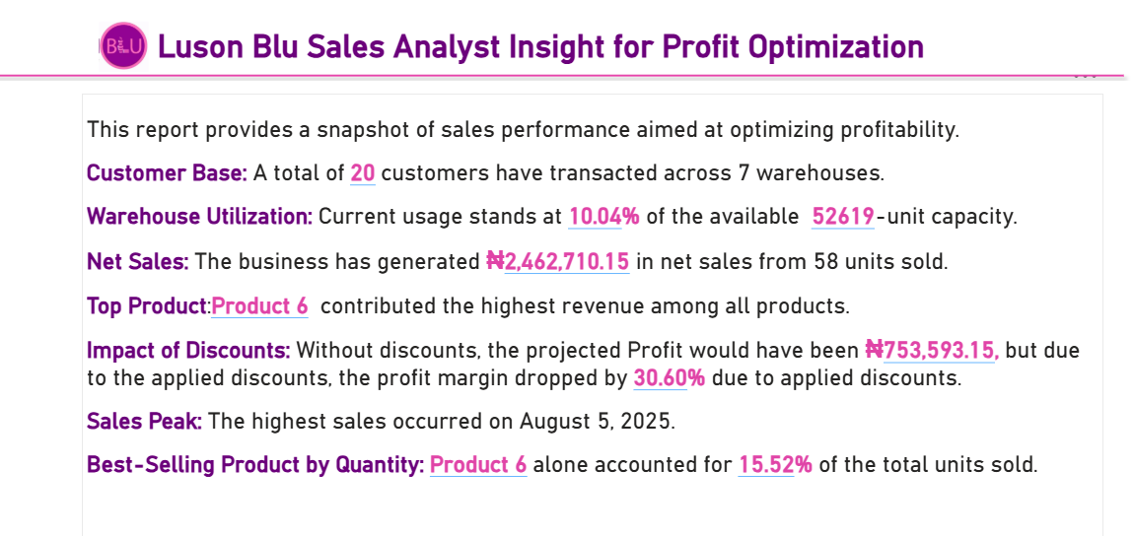

**Surprise Insight**

One mid-range product, though not among the top 10 by volume or revenue, delivered the highest profit margin, suggesting potential for strategic promotion or bundling.

**Deliverables**

Power BI pbix file with star schema and dynamic visuals

A one-page business insight summary

Ready-to-present dynamic dashboard for stakeholders